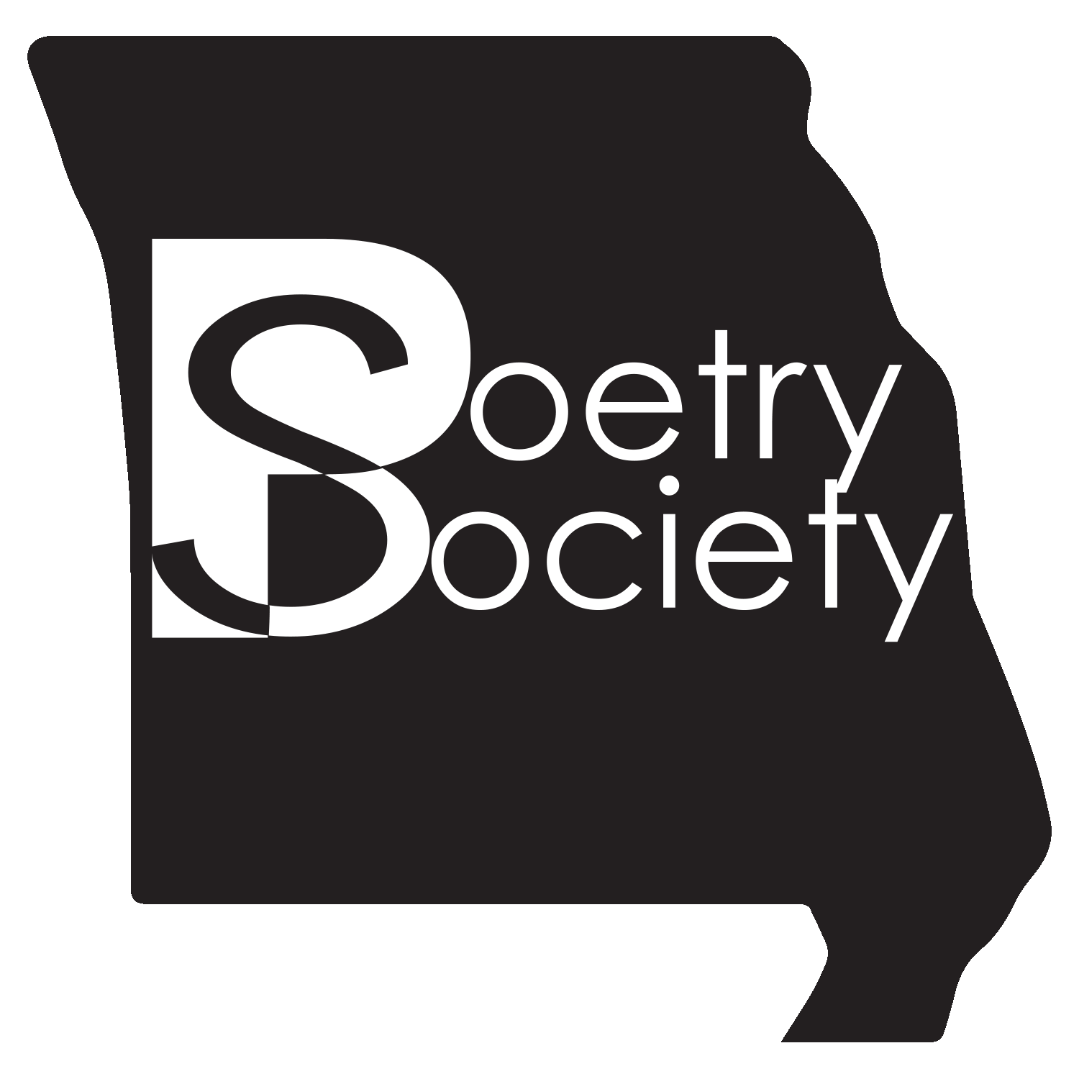

**Missouri State Poetry Society**

**Convention 2025**

Friday and Saturday Sept.19 and 20, 2025

Hosted by Lebanon Poets Society

Held at: Second Baptist Church Fellowship Hall

355 S. Madison Ave. Lebanon, MO 65536

Make hotel reservations at **Holiday Inn Express**

1955 W. Elm St., Lebanon

1-800-465-4329 or 417-532-1111

**Must book by August 29**

(mention Missouri State Poetry Society for special rate)

Please RSVP if coming to lachancenancy@outlook.com

Lunch provided in house for $11.00

(green salad, pasta, choice of 2 meats, garlic bread, dessert and drink)

Friday evening speaker: Phillip Howerton

Saturday afternoon speaker: Todd Sukany

***Bring lots of poems for four read a rounds.***

**Begins at 6 p.m. Friday evening**

**End at 3:15 Saturday afternoon**